Task 1



Name: Matthew Kamal Saad

Submitted to: Eng. Ahmed Saber
Date: 3/10/2025

Table of Contents

Text Formating in HTML 3
Special types of text 3
Practical Examples of Text Formatting Using Visual Studio Code 4
Media Tags in HTML 5
Iframes HTML 5
frame-Target for a link 6
Audio 7
Video 8

Forms 9
Forms HTML 9
Practical Examples of Forms using Visual Studio code 10
Semantic Html 11
References 12

HTML Formatting Elements

Formatting elements were designed to display special types of text:

Tags | Refer to
<b> | Bold Text
<strong> | Important Text
<i> | Italic Text
<em> | Emphasized Text
<mark> | Marked Text
<small> | Smaller Text
<del> | Deleted Text
<sub> | Subscript Text
<sup> | Superscript Text

Practical Examples of Text Formatting Using Visual Studio Code

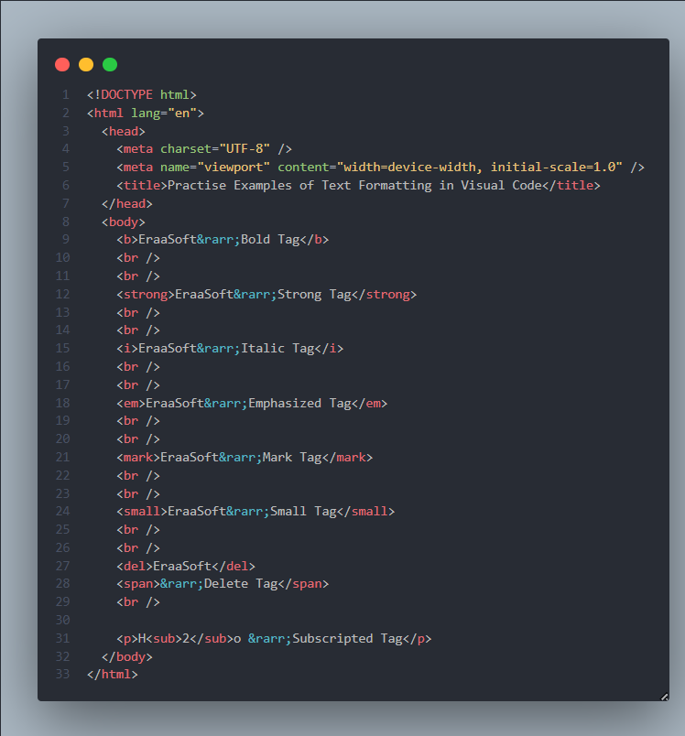

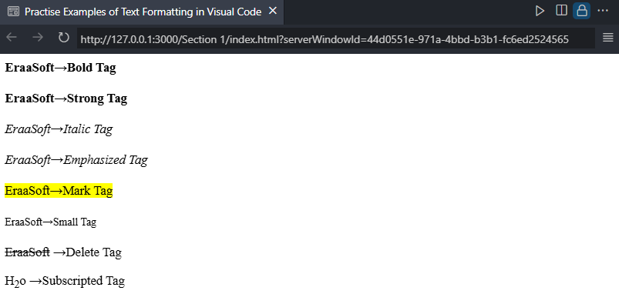

Media Tags in HTML

Iframes
Html iframes
The HTML <iframe> tag specifies an inline frame.
An inline frame is used to embed another document within the current HTML document.
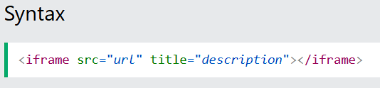

Practical Examples of iFrames Using Visual Studio Code
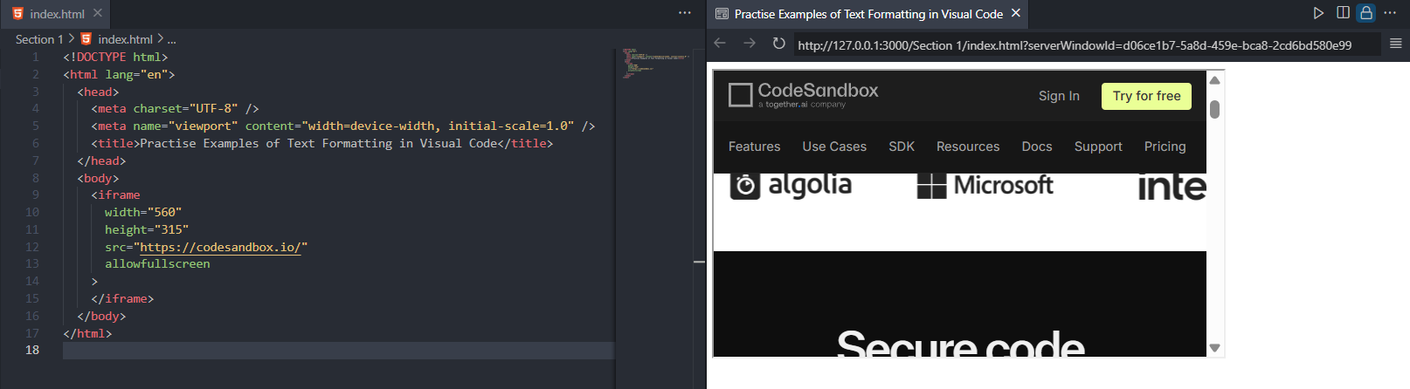

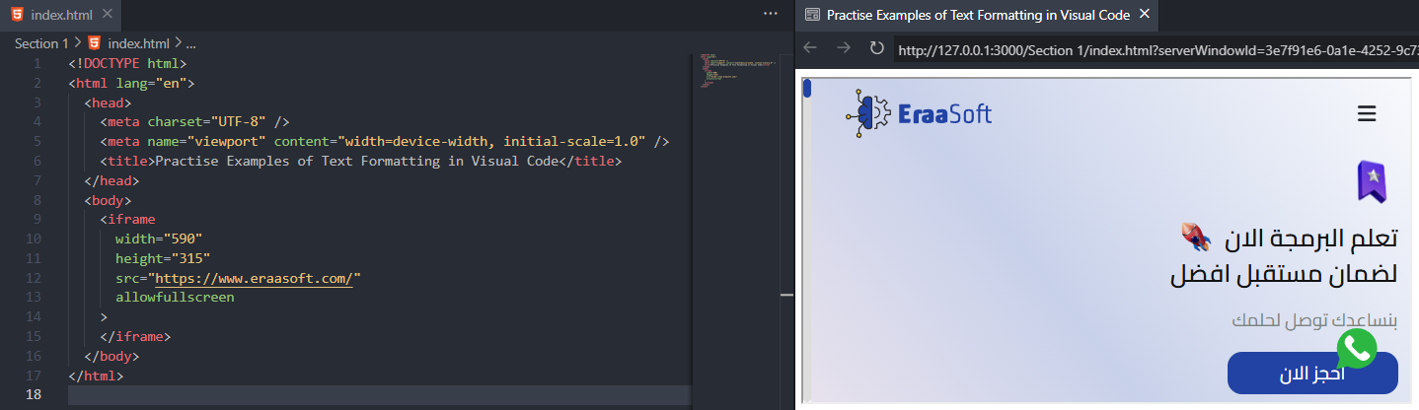

frame - Target for a Link
An iframe can be used as the target frame for a link.
The target attribute of the link must refer to the name attribute of the iframe:

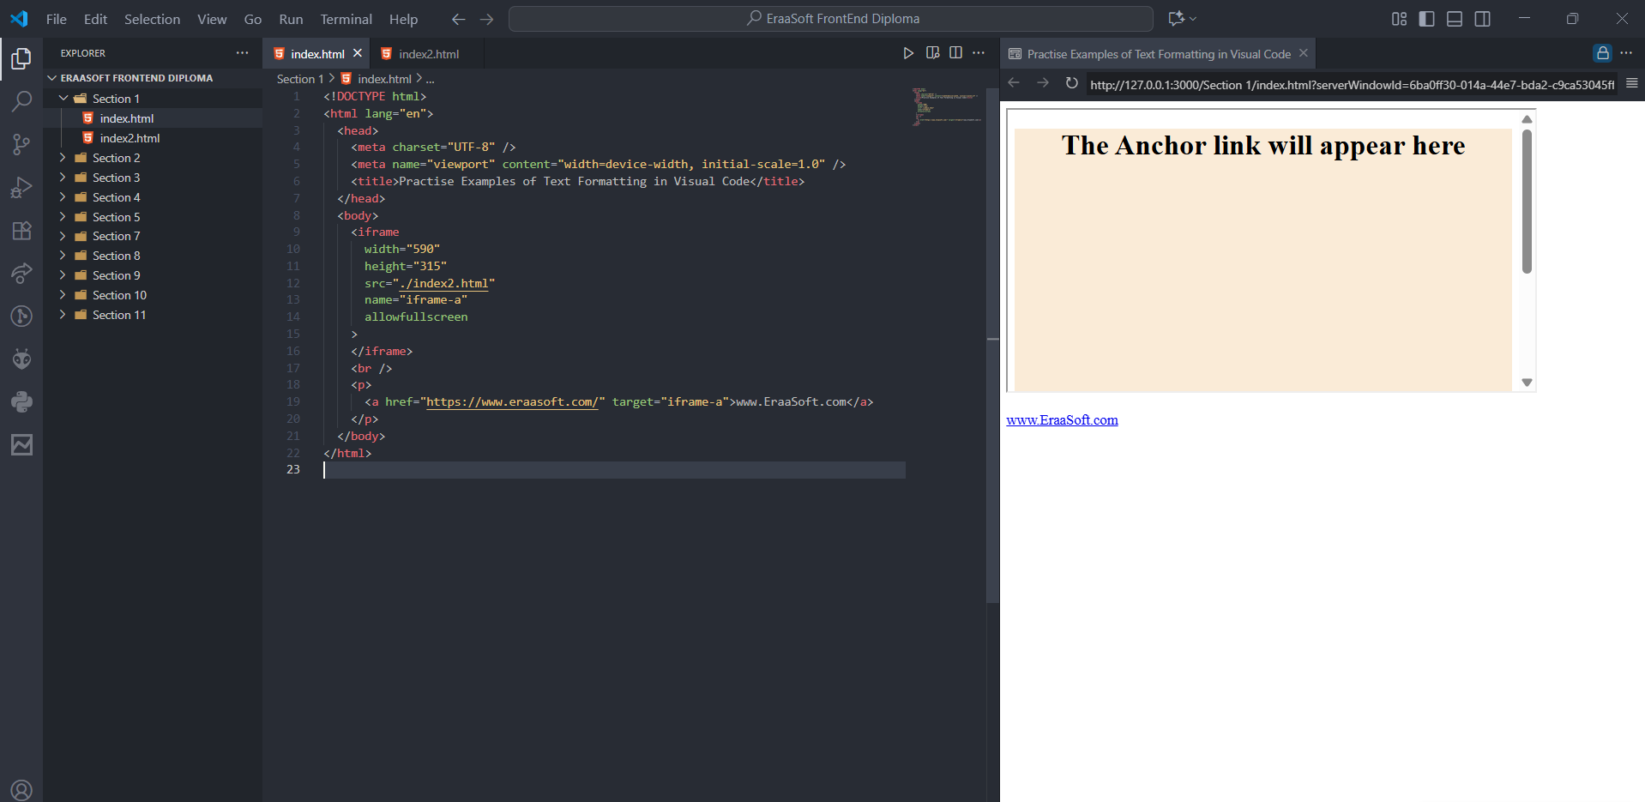
Practical Examples of iFrames Using Visual Studio Code

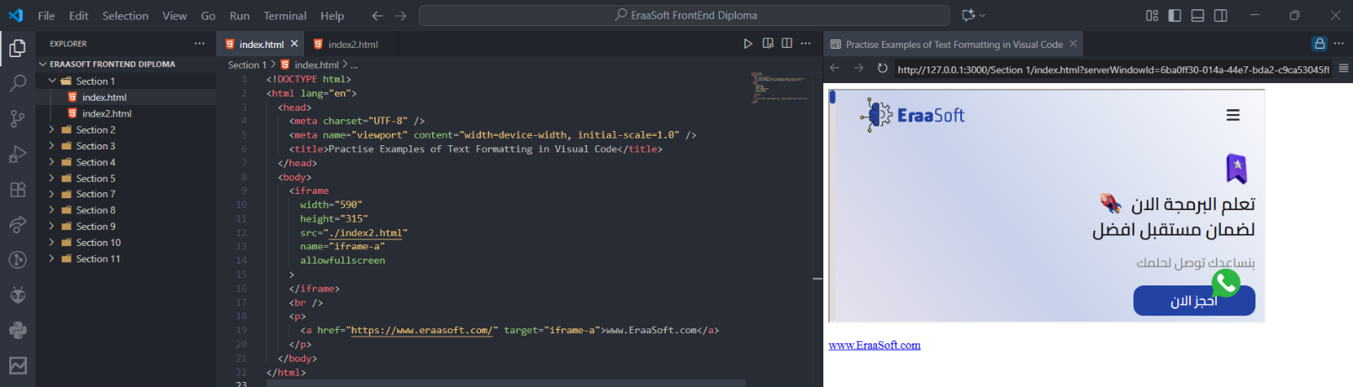
After Clicking on the Link
Audio

Html audio
To play an audio file in HTML, use the <audio> element
HTML Audio - How It Works
The controls attribute adds audio controls, like play, pause, and volume.
The <source> element allows you to specify alternative audio files which the browser may choose from. The browser will use the first recognized format.
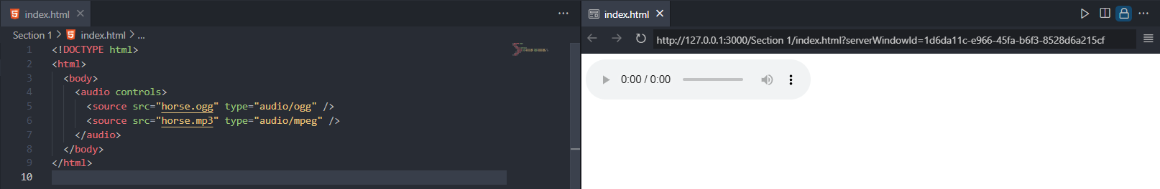

HTML <audio> Autoplay
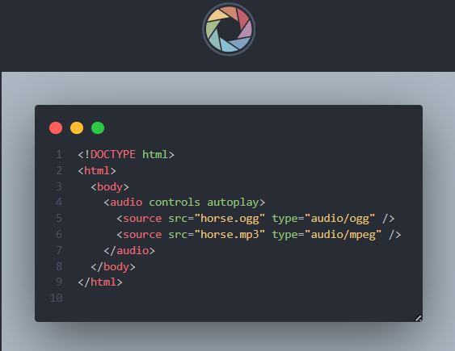
To start an audio file automatically, use the autoplay attribute

Video

Html video
The HTML <video> element is used to show a video on a web page.
How it Works
The controls attribute adds video controls, like play, pause, and volume.
It is a good idea to always include width and height attributes. If height and width are not set, the page might flicker while the video loads.
The <source> element allows you to specify alternative video files which the browser may choose from. The browser will use the first recognized format.
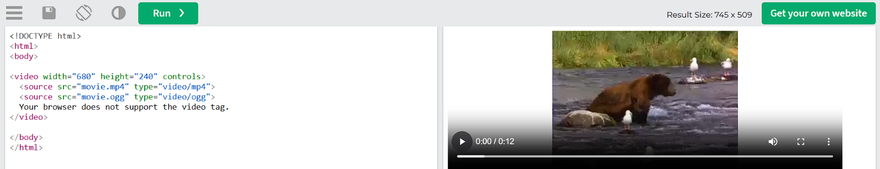

HTML <video> Autoplay
To start an video file automatically, use the autoplay attribute
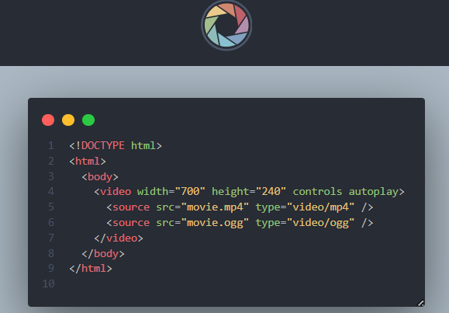

Forms in HTML
HTML forms are used to collect user input on web pages. They are defined using the <form> tag and can contain various interactive controls for users to input data.
Key Components of an HTML Form:
- <form> element:
This is the container for all form elements.
- <input> element:
This is a versatile element used for various input types, specified by the type attribute:
  - type="text": For single-line text input.
  - type="password": For password input (characters are masked).
  - type="email": For email address input.
  - type="number": For numerical input.
  - type="checkbox": For selecting multiple options.
  - type="radio": For selecting a single option from a group.
  - type="submit": For a button that submits the form.
  - type="button": For a generic clickable button.
  - type="hidden": For data that needs to be sent but not displayed to the user.
- <label> element:
Used to associate a descriptive label with a form control, improving accessibility. The for attribute of the label should match the id of the input it describes.
- <textarea> element:
For multi-line text input.
- <select> element:
Creates a dropdown list for selecting options.
  - <option> elements define the individual choices within the dropdown.
  - <optgroup> can be used to group related options.
- <button> element:
Creates a clickable button. It can be used as a submit button or for other actions.
- <fieldset> and <legend>:
  - <fieldset> groups related form elements, visually organizing the form.
  - <legend> provides a caption for the <fieldset>.

Practical Examples of Forms Using Visual Studio Code

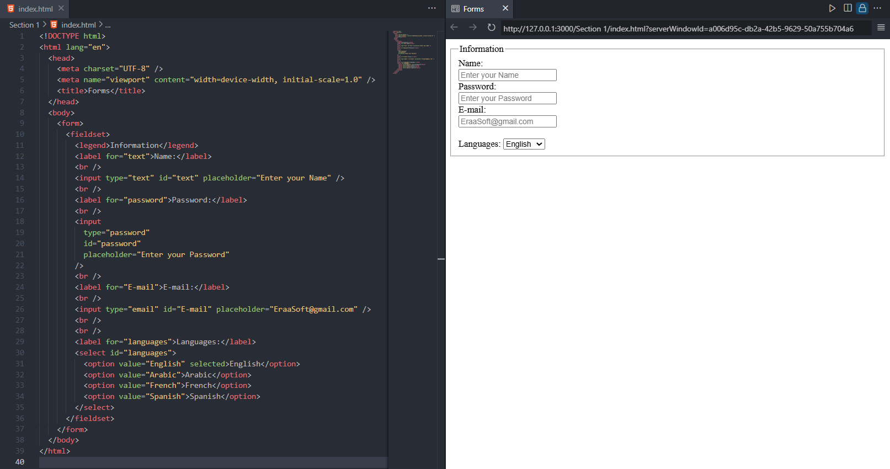

Semantic HTML

What are Semantic Elements?
A semantic element clearly describes its meaning to both the browser and the developer.
Examples of non-semantic elements: <div> and <span> - Tells nothing about its content.
Examples of semantic elements: <img>, <table>, and <article> - Clearly defines its content.

Semantic Elements in HTML
Many web sites contain HTML code like: <div id="nav"> <div class="header"> <div id="footer"> to indicate navigation, header, and footer.
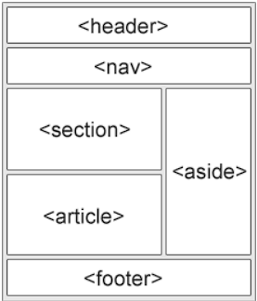
In HTML there are several semantic elements that can be used to define different parts of a web page:
- <article>
- <aside>
- <details>
- <figcaption>
- <figure>
- <footer>
- <header>
- <main>
- <mark>
- <nav>
- <section>
- <summary>
- <time>

References

- https://www.w3schools.com/
- https://developer.mozilla.org/en-US/

